Smart Scale

Gage Hansberry, Evan Kosmos, Ben Markoe, Riley Mollon, Nick Ricario, Michael Shaffery

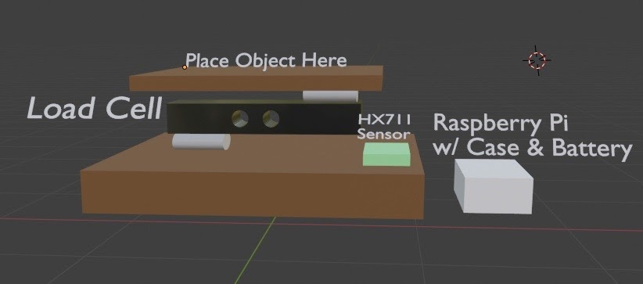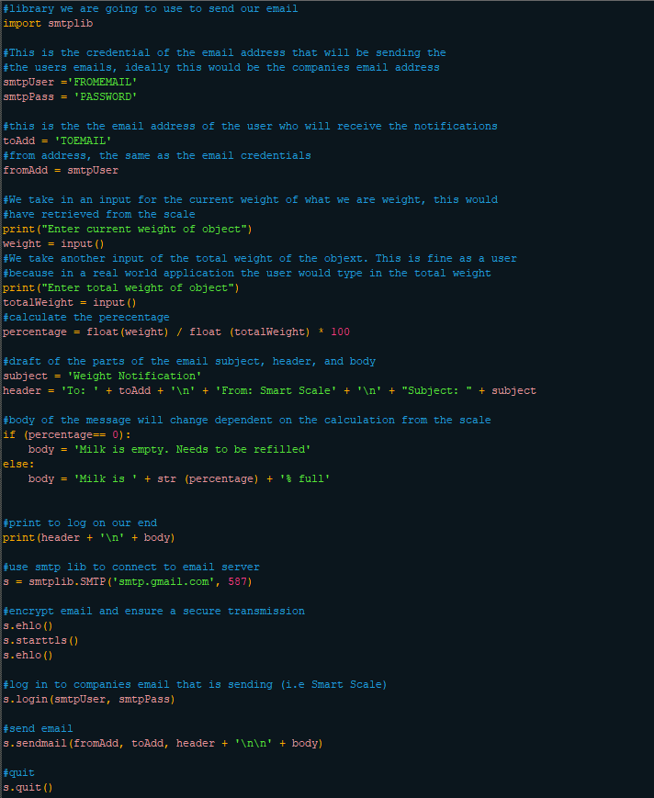The goal of this project was to create a smart scale which would send alerts to the users linked phone or another device. The main application of such a device is to create a dynamic shopping list based on a configurable threshold, potentially through integration with a refrigerator or other food storage space. This would be achieved using a simple scale connected to a Raspberry Pi, which would run a python script to handle input from the scale and send an alert to the user when needed. These alerts would be sent through text message as a proof of concept, but commercial implementation would demand pushing the alerts to the user through a mobile application, simultaneously saving low stock items to a shopping list for future reference. The particular scale and use of Raspberry Pi hardware are relatively arbitrary, so the product could in theory be deployed on almost any hardware to fit a wide array of products. However, due to complications with acquiring materials and meeting to assemble the product due to the recent COVID-19 pandemic, some major cuts had to be made to the project. Therefore, the scale was unable to be obtained, and the system will instead simply send an E-mail to the user. However, if the scale were to be added in future, it would be able to be linked to the existing software in place to push the notification.

Video: <https://www.youtube.com/watch?v=YL1emYH08Vo>